***Name:Mohd Zaki Mehtab Qureshi Roll No: 19CO40  
Subject: SMA Class: BECO***

***Experiment No: 03***

***Aim:*** *Data Collection-Select the social media platforms of your choice(Twitter, Facebook, LinkedIn, YouTube, Web blogs etc) ,connect to and capture social media data for business (scraping, crawling, parsing).*

***Theory:***

***Social Media Scraping of samsung news channel using Python:***

1. ***Instagram:***

**import instaloader**

**import pandas as pd**

**from prettytable import PrettyTable**

**x = PrettyTable()**

**bot = instaloader.Instaloader()**

**profile = instaloader.Profile.from_username(bot.context, “samsung”)**

**x.field_names = ["Attribute", "Details"]**

**x.add_rows(**

**[**

**["Username: ", profile.username],**

**["User ID: ", profile.userid],**

**["Number of Posts: ", profile.mediacount],**

**["Followers Count: ", profile.followers],**

**["Following Count: ", profile.followees],**

**["Bio: ", profile.biography],**

**["External URL: ", profile.external_url],**

**]**

**)**

**print(x)**

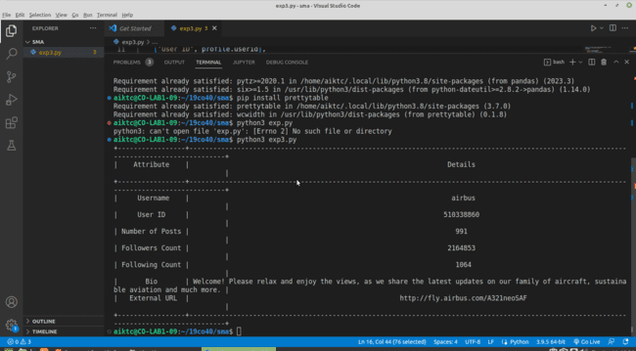

**3.Facebook:**

**from facebook_scraper import get_posts**

**import pandas as pd**

**fbPosts = []**

**for post in get_posts('samsung', pages=10):**

**fbPosts.append(post)**

**print(print(f"Latest posts:\n {pd.DataFrame(fbPosts)}"))**

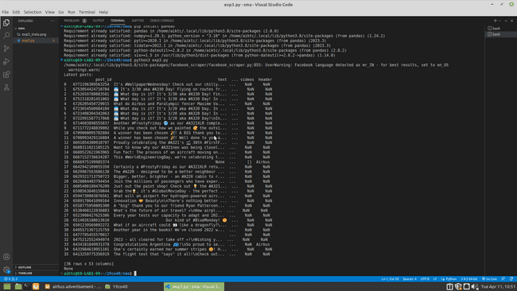

***Conclusion:***

*We have successfully collected samsung social media data from websites like Instagram, Twitter, and Facebook. In order to connect and capture social media data for businesses (scraping, crawling, parsing).*